# Configuring SalesForce Account

Follow the instruction below to setup your free trial developer account with SalesForce.com and configure demo to use your own credentials.

Step 1) Sign up for developer account at <https://developer.salesforce.com/>

Step 2) Once signed up, login to <https://www.salesforce.com/> with your new credentials

Step 3) Generate new Security Token to be able to login remotely

1. Select “My Settings” from drop-down next to your name on **top right corner**

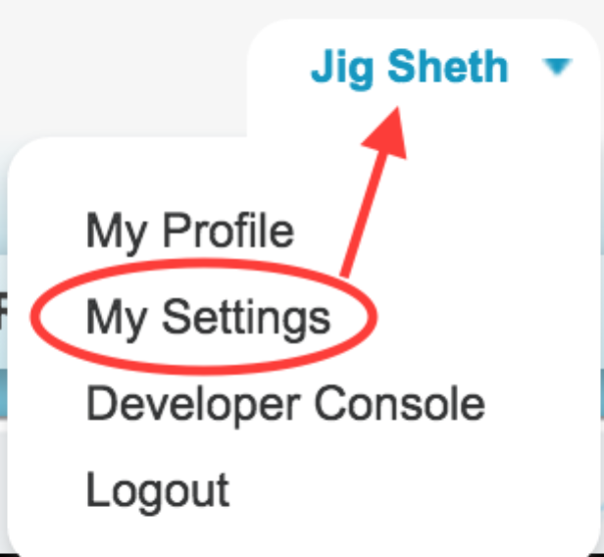

1. Select “Personal” -> “Reset My Security Token” from **left navigation bar**

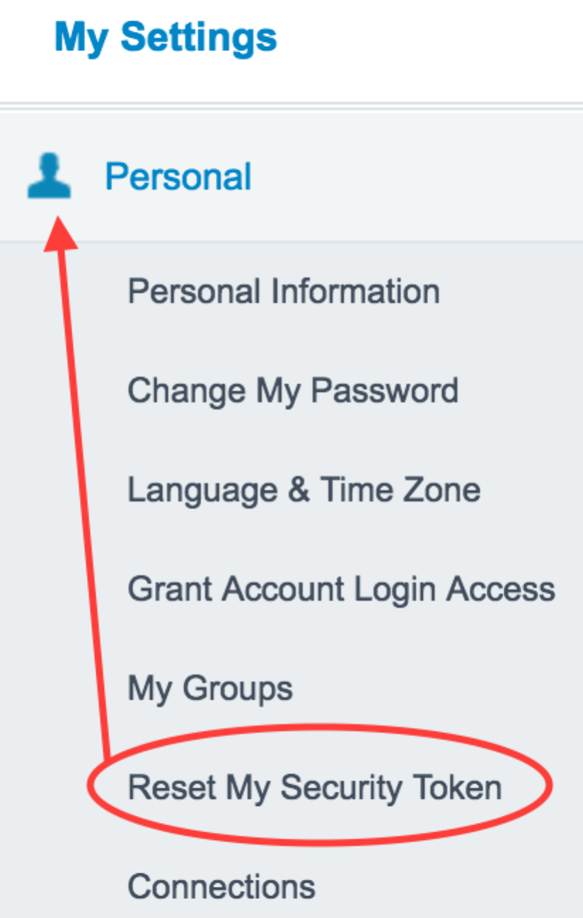

1. Once you submit a request to “Reset Security Token”, you will get email with your token information.

Step 4) Create Connected Application

1. Select “Setup” from link next to your name on **top right corner**



1. Select “Build” -> “Create” -> “Apps” from **left navigation bar**

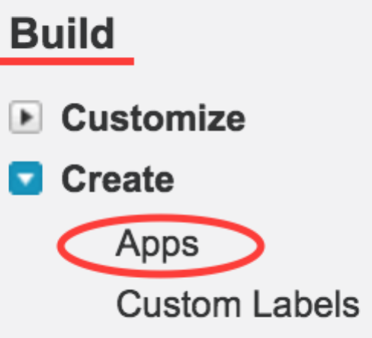

1. Create new connected app with just basic dummy information for following fields: Connected App Name, API Name, Contact Email, Enable OAuth Setting and Selected OAuth Scope.

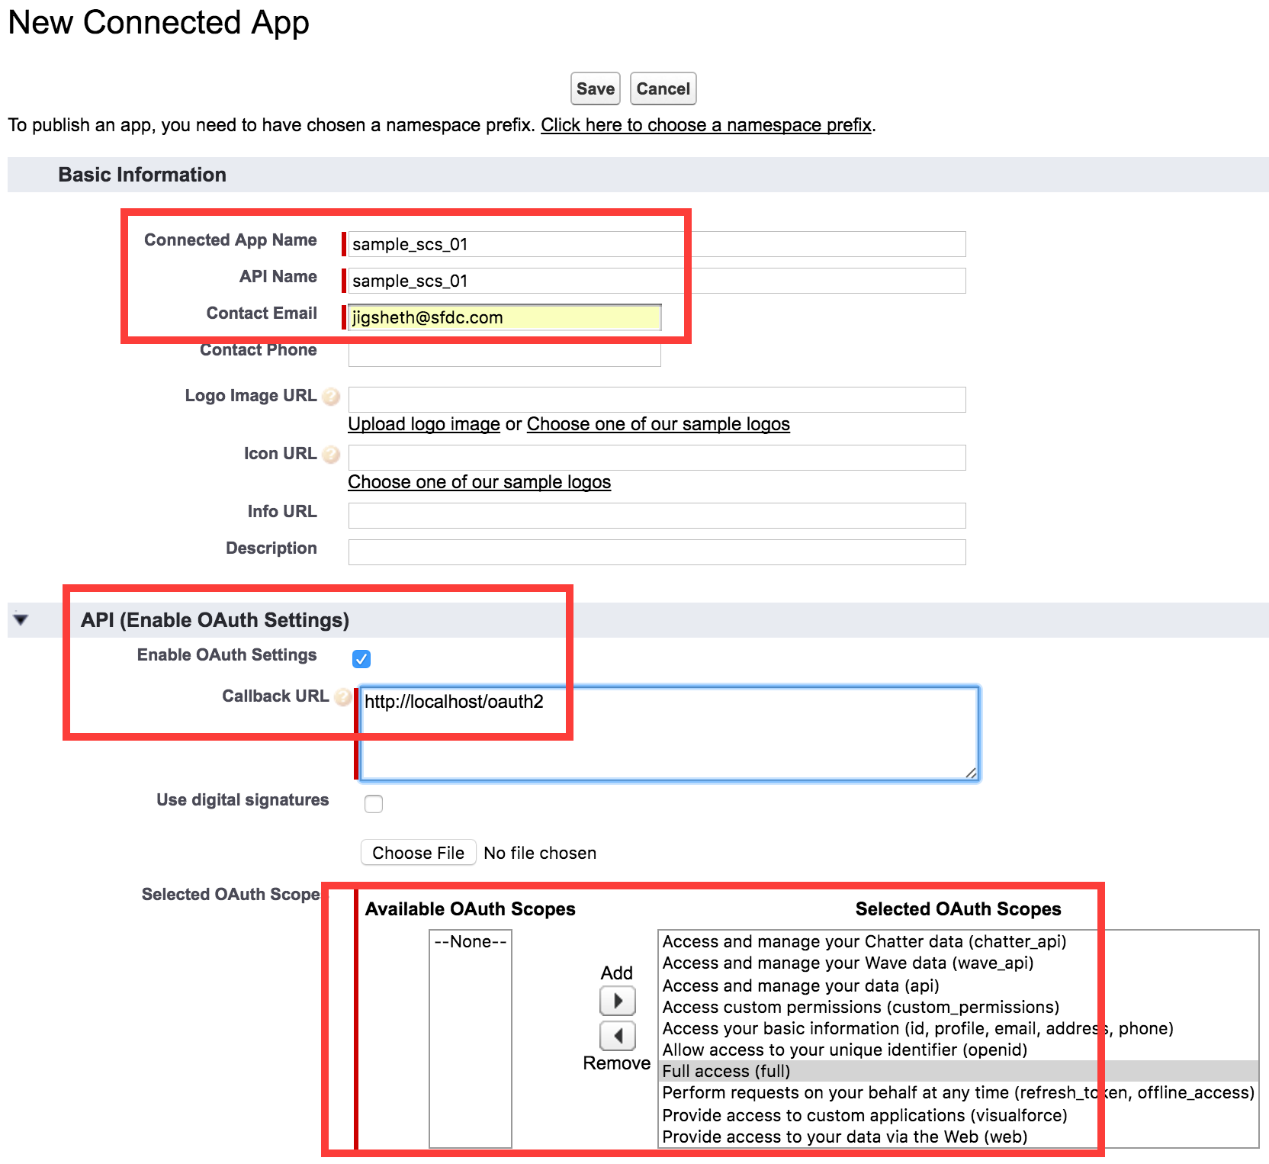

1. Go back to application definition to view the OAuth **Consumer Key and Consumer Secret**

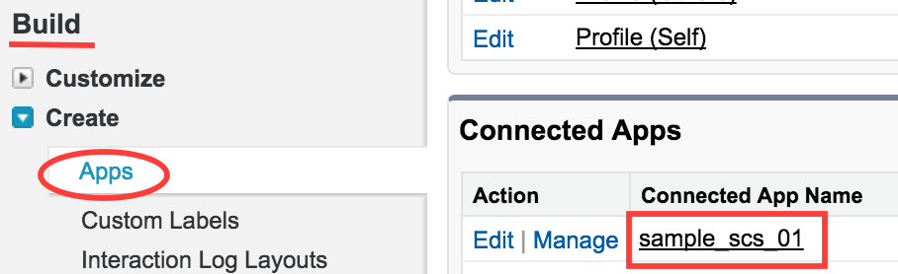



Step 5) Fork the Configuration Repo (https://github.com/jigsheth57/config-repo) used by the Spring Cloud Configuration Server and update the **authService.yml** file

1. Replace the following values with your credentials:

sfdc.client_id -> should point to **your Consumer Key** from previous step

sfdc.client_key -> should point to **your Consumer Secret** from previous step

sfdc.uid -> should point to you **userid** to login to sfdc.com

sfdc.pwd -> should point to your **password+security token** (e.g. if password is “Pivotal1234” and security token is “mpY9LIqi4zImvqRZI8zYP2p3”, than value should be “Pivotal1234mpY9LIqi4zImvqRZI8zYP2p3”

1. Update the Configuration Server Service Instance to use your own git hub configuration repo. If you use “**deploy.sh**” to deploy to PCF, update the “deploy.sh” to use your repo.
2. If you run locally using Docker, update the “docker-compose.yml” and replace the value for **SPRING_CLOUD_CONFIG_SERVER_GIT_URI** with your repo